M 051 From B066 Turning Defenders From Wide, the line pass and cross. M051 Turning Defenders is Phase ii of B066 used in the same session.

Requirements: Half a pitch, a goal with net and keeper, two markers (three touch posts, players with soccer balls.

General Scenario: Player (A) runs to a defender, shown in (Red), turns on the defender and receives a pass from Player (B). Player (A) controls the ball, turns the defender then passes down the line, and breaks inside for a return pass.

Play commences: You have just used B066 Turning Grid now we turn this into a Match Practice Grid

Here is the previous grid…
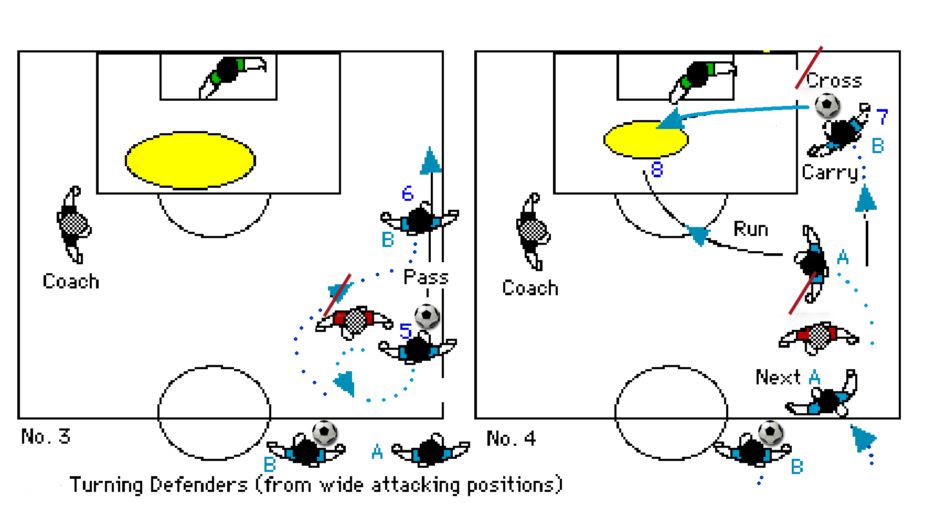

Set up for M051
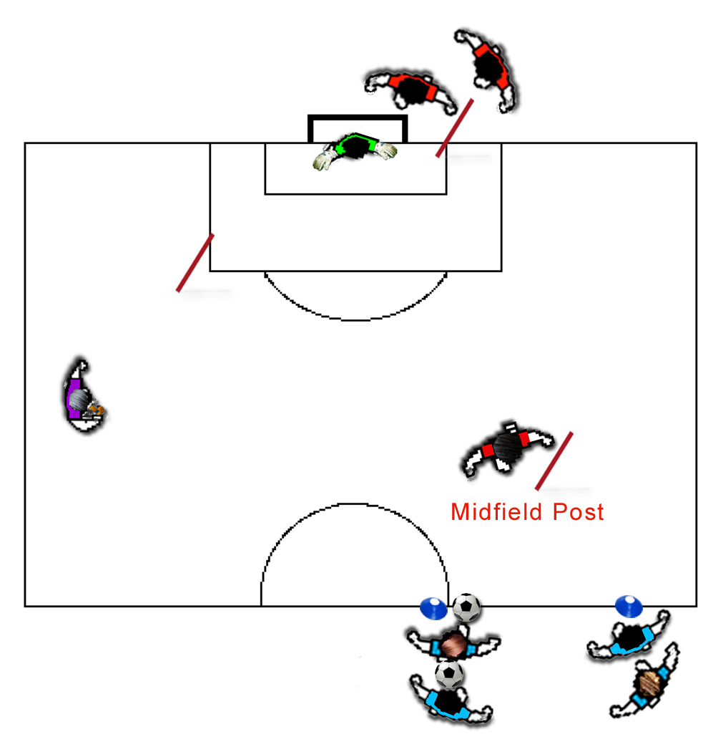
Play beings: When a defending player, Defender (B1) moves to the midfield post. The attacking team move into the grid one player Attacker (A1) running in and turning, the next attacker (B2) passes to this attacker, and then sprints around the Midfield Post.

These then make a switched attack down the wing with one attacker cutting into the penalty area.
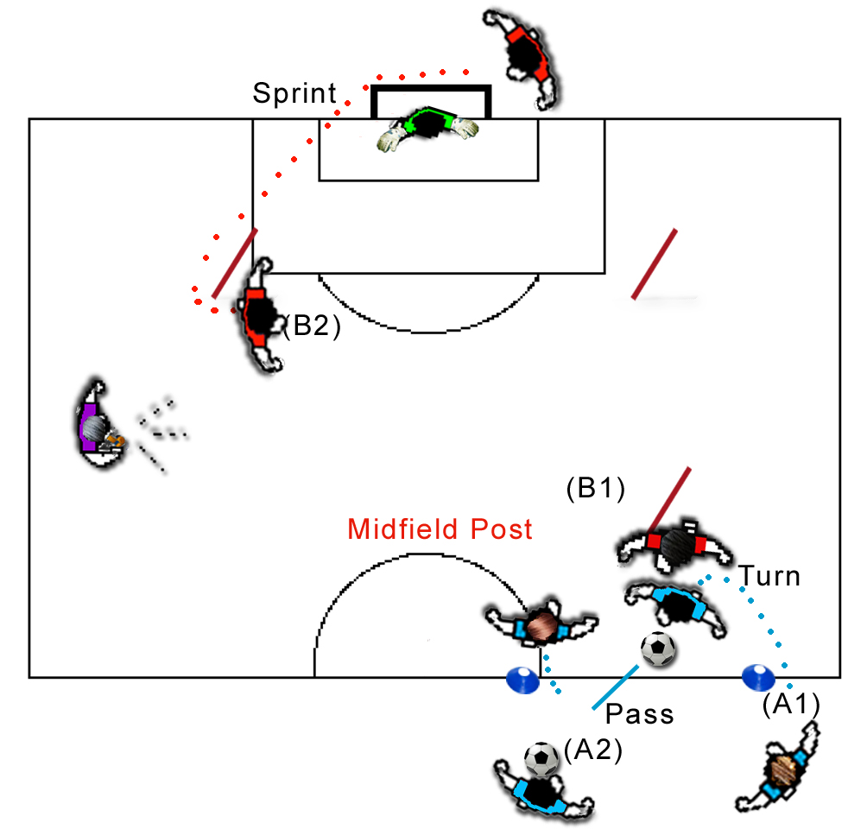

They then make a line pass and switch as in Grid B066

The Attackers then break into the penalty area where a defender (B2) has sprinted in to defend. The attackers in a 2 v 1 Attacker (A2) must cross the ball for the other attacker. (Then moves to become a defender).

The defender can touch either to stop the attack (YOU CAN CHANGE THIS TO BE TACKLING etc.)

The previous attacker (A1) usually the one crossing the ball must swap with the previous defender (B1) and get to the midfield post as soon as possible.
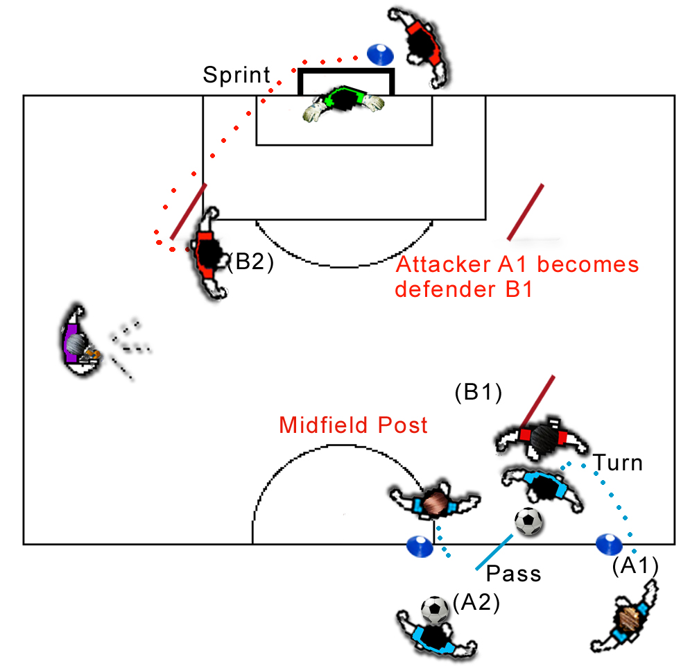

The previous defender (B1) moves to join the attacking team as (A2).

The Attacker (A2) then moves to the defenders marker and becomes a defender (B2) ready to sprint in on the next set or call by the coach.

Defender (B2) must run around touch post before entering the grid and before assisting in defence of the goal as defender (B2). This player then moves to become an attacker after receiving the ball from the previous set.

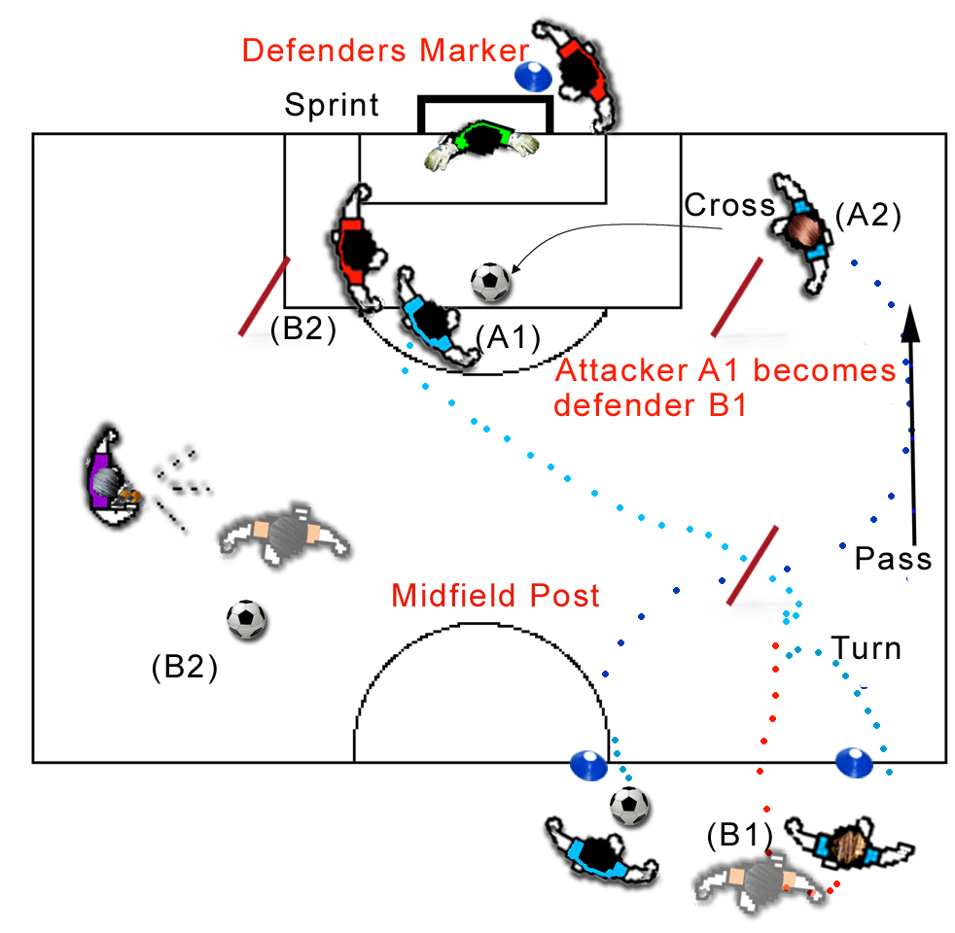

Coaching Points - Defensive skills, are no longer restricted, so attacking ability in turning the defender should be more difficult. We now have three defenders (two under pressure (touching a marker - and one attacker (A) remembering to change roles). Plus our initial defender whom can be encouraged to be more aggressive, or you can leave as a passive defender.

Again look for good line passing from attacker (A1) or chipping crossing skills from the winger (A2), followed by good timing of the run onto the crossed ball, and strong finishing, especially now that a defender (B2) is in place.

See if you are still getting good crosses with attacker (A2), under pressure from Defender (A). The whole team should be working under pressure and at speed, there is no delay in the attack movement - once the line pass is made the next pair, if ready, can start their attack.
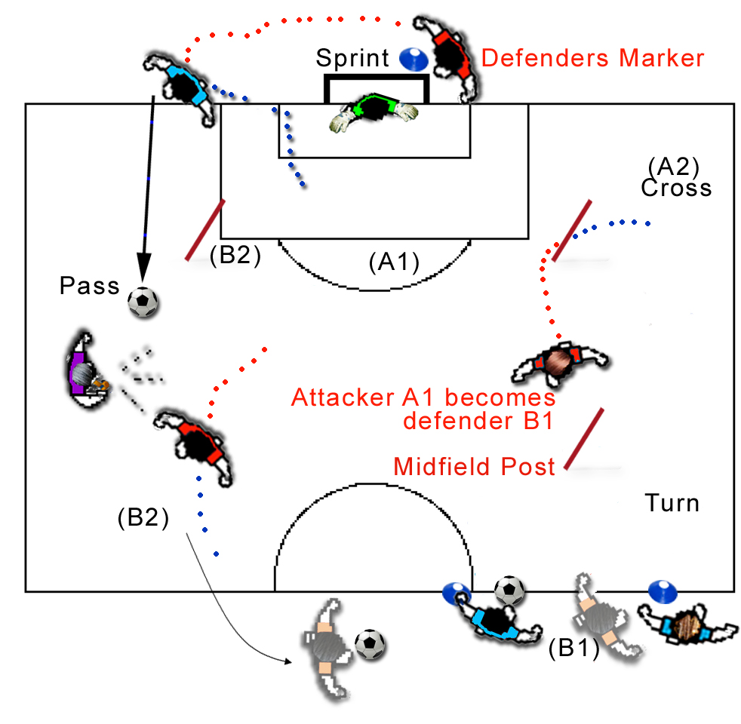
You may find the pressure quite severe on younger players, even the senior experienced players will forget their roles until you run this grid several times. (That is why I run this after the Ball Skills Grid B066)

For Youth Teams = You could run this grid using two set defenders the one at the midfield post fairly passive the other active but both must touch posts after every attack.

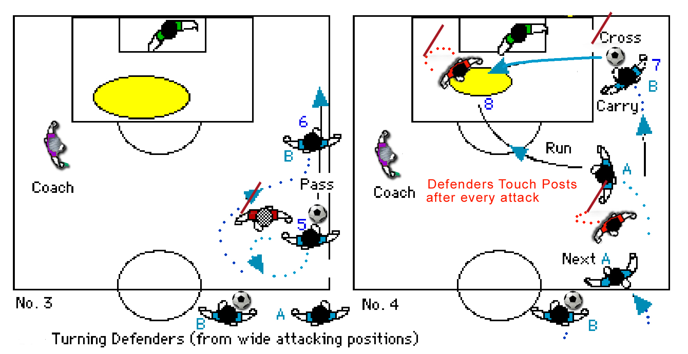

Developments:
i. Allow Tackling

ii. Keep grid moving if defenders are not in place too bad!

